

**Wildlife Project**

By:

Devomech Solutions Pvt. Ltd.

Date: 28-04-2023

# Current Progress:

* Connected the ESP module with internet using SIM7000G (GSM).

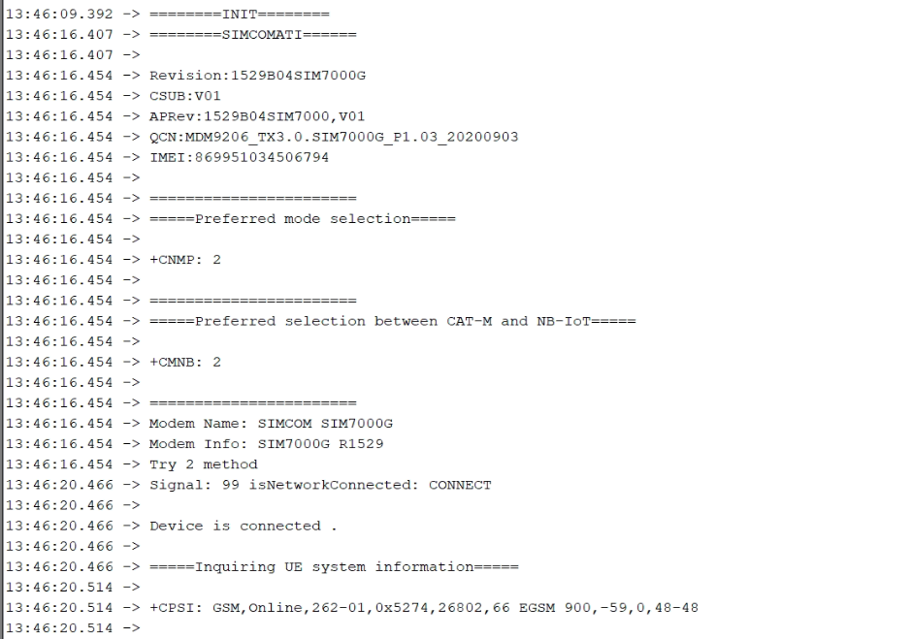

Figure 1 GSM Connection

* Previously we were using the wifisecureclient library to communicate with the MQTT broker on a secure TLS/SSL port. Now in case of GSM we don’t have any library to integrate the TLS certificate.

# Task for next week

* Resolve the GSM connection issue with MQTT broker with TLS/SSL.